**SAN DIEGO SEND-OFF**

*Friday, May 31st, 2024*

If you are receiving this email, it is because you are a client and/or friend of the La Jolla Private Wealth Group of Wells Fargo Advisors. The idea behind the ***San Diego Send-Off***is to keep you abreast of interesting trends we are seeing in the market/world.

Best Regards,

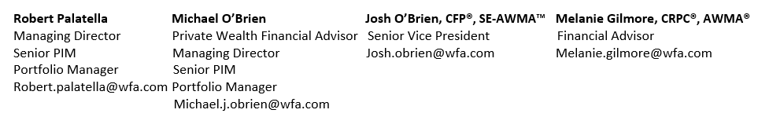

**La Jolla Private Wealth Group:** [2024 Forbes Best-In-State Wealth Management Teams](https://www.forbes.com/profile/michael-obrien/#59bd938c42f0). Source: Forbes.com. 2024 Forbes Best-in-State Wealth Management Teams: Awarded January 2024; Data compiled by SHOOK Research LLC based on the time period from 3/31/22-3/31/23. Fee paid for use of marketing materials. The Forbes Best-In-State Wealth Management Teams rating algorithm is based on the previous year’s industry experience, interviews, compliance records, assets under management, revenue and other criteria by SHOOK Research, LLC. Investment performance is not a criterion. Self-completed survey was used for rating. This rating is not related to the quality of the investment advice and based solely on the disclosed criteria.

**The cost of buying a new car hasn’t changed much…but insuring it has**

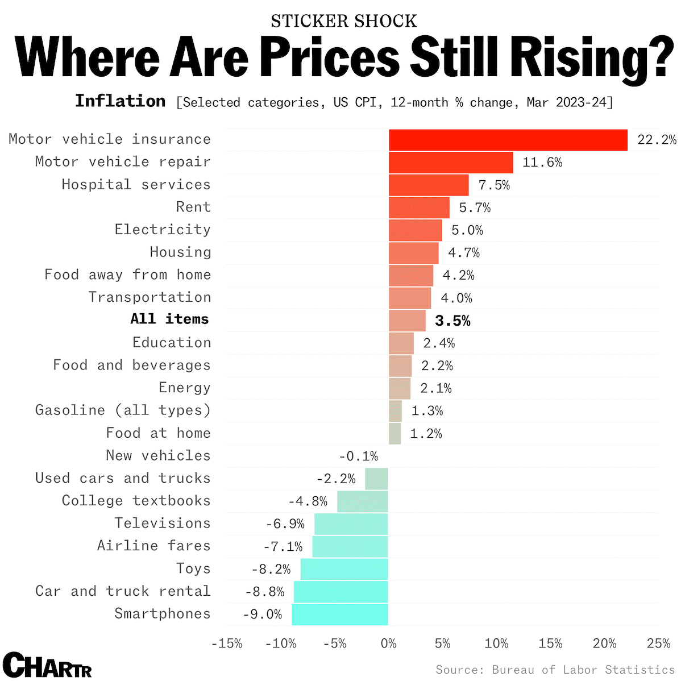

**Over the past 10 years, rare whisky has been the only luxury good to outperform the S&P 500**

**Increased demand for electrification, cooling, & back-up power supply in support of data centers should be tailwind for the Electrical Equipment, Building Products, & Industrial Machinery sub-sectors**

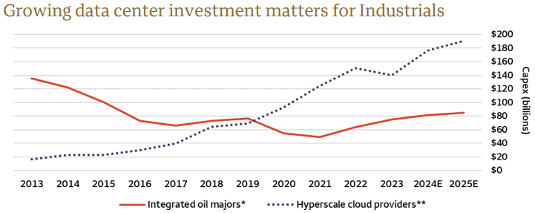

Sources: FactSet and Wells Fargo Investment Institute. Based on calendar year data: 2024 and 2025 data represent consensus estimates from FactSet. Capex = Capital Expenditures. *Four largest global integrated oil majors by market capitalization (BP Plc, Chevron Corporation, Exxon Mobil Corporation, Shell Plc). **Four largest cloud infrastructure companies by market capitalization (Alphabet Inc., Amazon.com, Inc, Meta Platforms Inc, Microsoft Corporation). Forecasts and targets are based on certain assumptions and on views of market and economic conditions which are subject to change.

**Higher rates and excess office/retail supply has hurt real estate related equities**

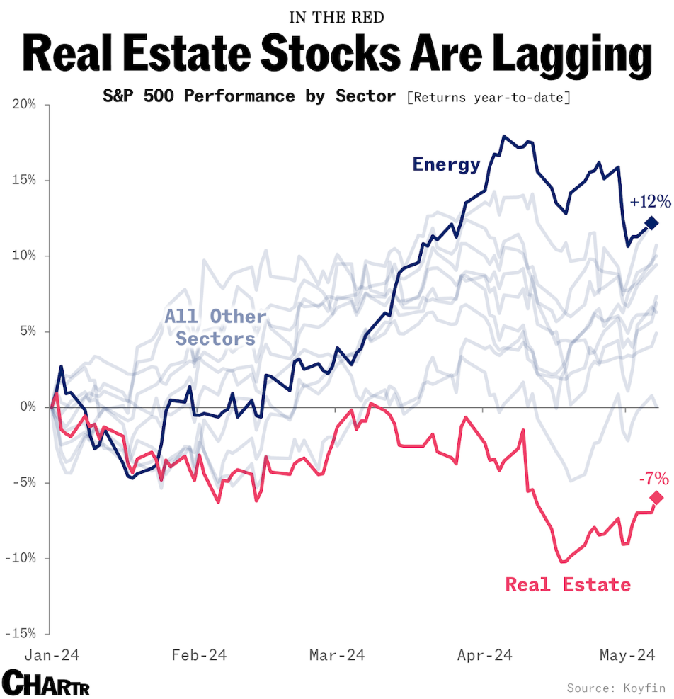

**As regional banks pull-back on lending to private businesses, non-bank lending has grown rapidly**

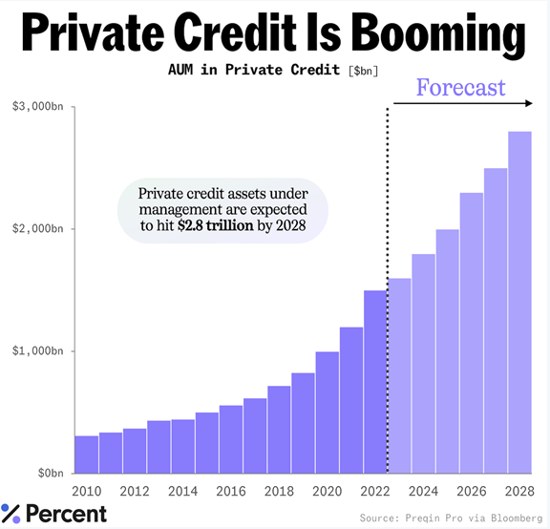

**U.S. oil producers have focused on profitability instead of increasing capital expenditures alongside rising oil prices**

Sources: Energy Information Administration, and Wells Fargo Investment Institute. Monthly data from January 1, 2012, to February 29, 2024. Chart shows rig counts from the following regions: Permian, Niobrara, Haynesville, Eagle Ford, Bakken, Appalachia, and Anadarko. The commodities markets are considered speculative, carry substantial risks, and have experienced periods of extreme volatility. Investing in commodities is not appropriate for all investors. The commodities markets are considered speculative, carry substantial risks, and have experienced periods of extreme volatility.

Super-cycle = If you look at commodity prices over the very long term (hundreds of years), it becomes evident that they tend to move in overall bull and bear cycles, some lasting decades. These are super-cycles.

**As the population ages, the health sector is anticipated to drive employment growth in the future**

**Homeowners insurance in certain California zip codes is becoming hard to obtain**

**About four-in-ten U.S. Tik Tok users say they regularly get news there**

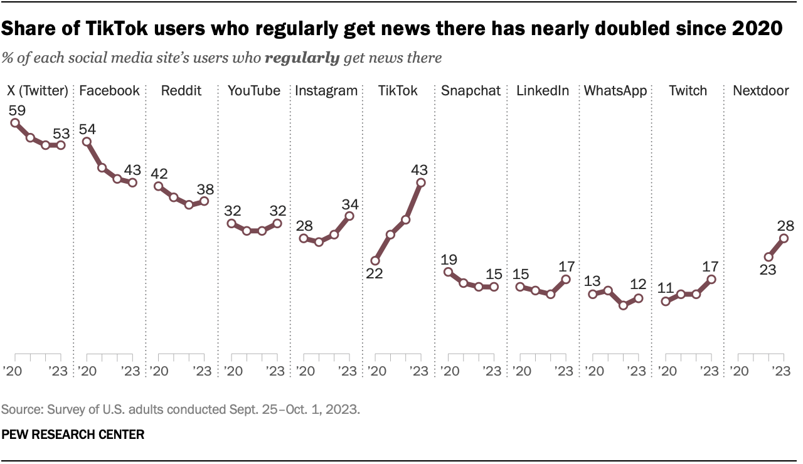

**As a response to unaffordable housing, Millennials are buying homes with friends**

**Articles of the month:**

**Estate plan glossary: 10 estate planning definitions to know**

[Click Here to Read](https://lifescapes.wellsfargoadvisors.com/estate-planning-glossary/)

**Maybe Baby Boomers Won’t Tank the Stock Market by Cashing Out**

[Click Here to Read](https://www.ai-cio.com/news/maybe-baby-boomers-wont-tank-the-stock-market-by-cashing-out/?fireglass_rsn=true)

The opinions expressed here reflect the judgment of the author as of the date of the report and are subject to change without notice. The material has been prepared or is distributed solely for information purposes. Please note that we are not responsible for the information contained on the listed web site(s). The site(s) is/are provided to you for informational purposes only.